Comparative Study- BRNN LSTM for RIS

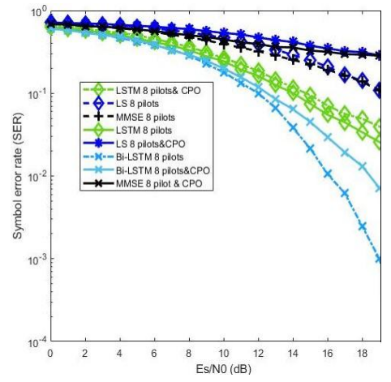
SER vs Es/N0 (dB)
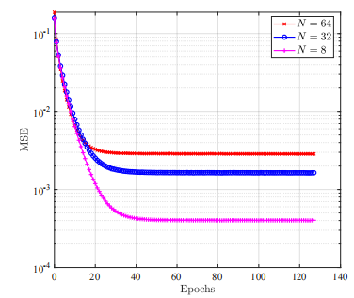
MSE vs no. Of epochs (N: no. Of elements in RIS)

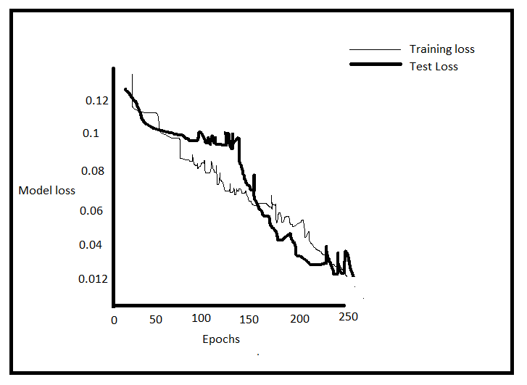
Training loss vs Path loss

